**5.0 DOCUMENTATION OF THE CURRENT SYSTEM**

**5.1 Description of the Current System**

In Global City Innovative College, the system where student evaluate their professors is already in place. However on a higher level, the evaluation of faculty heads and ICD Associate Director(s) to the faculty members is currently operational under manual process. The faculty heads has to go and observe the professors how they handle their classes, and the latter will be graded based on their teaching performance. The evaluators will have the forms with them for actual grading. It is critical since the professors need to meet the criteria of providing proper education and it will show their expertise in delivering information to the students On a wider scope of evaluation, It will also concern their character including the way they get along with students, coworkers and superiors. The issues in this phase that has to be addressed is that the faculty heads and directors have to be available in order to go to each classrooms. So instead of doing other equally important duties, they have to find time to do this. All these evaluation forms are then gathered and consolidated by the MIS team. This is the bottleneck of the process because here, it takes longer time before they finally give it to HR for report generation. The whole process is tasking and needs a lot of internal arrangement to be able to meet availabilities of concerned teams before the final result of evaluation gets finalized.

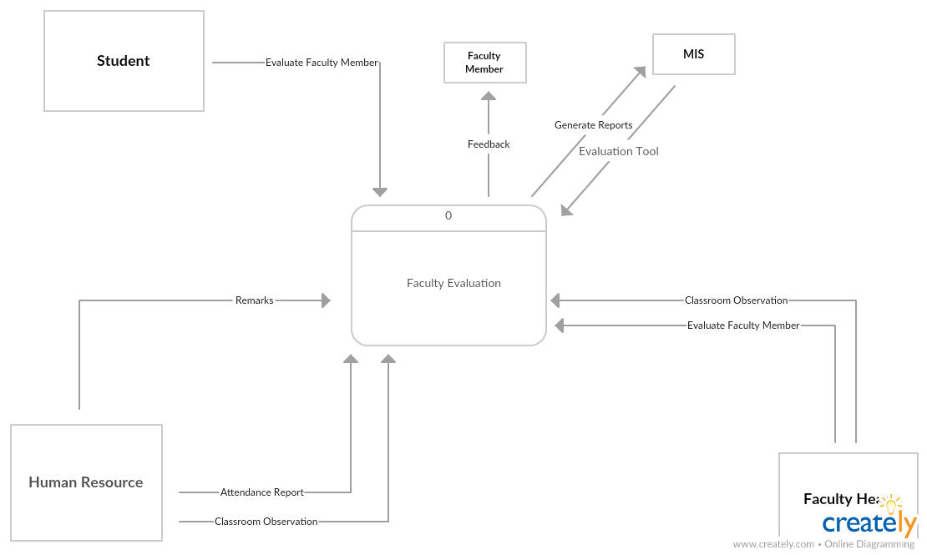

**Figure 5-1 Context Diagram of the Current System**

The diagram shows that the Faculty evaluation is mainly the feedback on faculty members. It concerns the Faculty Head, the MIS Team and the HR Department. The students, currently having their own system of evaluation only have to make their own appraisal report and enter it to the system. On the other hand, the Faculty head has to physically do the classroom evaluation and should be present in class in order to make the evaluation. The MIS Team generates the report and the HR needs to make their own classroom observation and has to cover attendance reports plus make their own remarks to complete the whole cycle of Faculty Evaluation. Faculty evaluation does not only give merits to the professors, it is also the measurement of the whole school’s performance and a guide to set new goals and be competitive to other schools in terms of providing quality education.

**5.2 Hardware and Equipment Setup**

The current system of evaluation only involves PCs and printers. The Forms, pen and paper are other essentials of the whole process. Other than that, whatever physical items will be needed will be considered part of the process but may or may not be considered mandatory.

**5.3 Software and Applications Being Used**

The existing process has a system in place for the student-faculty evaluation. This is being run by Microsoft Visual Basic and an SQL database. On another hand, the manual process uses MS access to generate reports. The MS access is capable to address all related updates and consolidation to provide necessary output. All the concerned departments only rely on this one to cover the full evaluation cycle.

**5.4 Personnel**

**Students**

Evaluation is the time for students to provide accurate and meaningful feedbacks about their professors with regards to their way of teaching. The students should take this opportunity to voice out their opinions and suggestions for instructional improvements. At this period of time, students should be able to assess the performance of their teachers from the biggest details to the smallest like if he or she comes in prepared for class, can communicate properly, inspires students to be passionate and enthusiastic in the class and if the professor shows a good character, treating students with respect and compassion.

**Faculty Heads**

The Faculty Head will be the one to facilitate evaluation in another angle. They need to see that the faculty member is fit for the job and that they can contribute in giving quality education to the school. Through evaluation, the faculty heads and directors can also recognize professors who has done exemplary performance. This is the time when consideration for salary increase, bonuses, retention and promotion is being applied. When giving the rating, whether Excellent “Satisfactory” or “Not Satisfactory”, the Faculty head should have a valid explanation to back up the grade in order to lift the morale of the professor. It should be delivered in a pro-active, positive and professional approach.

**MIS TEAM**

For all evaluations, the scope is defined by the MIS Team. They make sure that the quality of the system, documentation, team participation, and user satisfaction count towards the grade. This is why it is critical for them to make the tally properly before they submit to HR for final review. They play a very important part because they ensure that all the important data is collected, processed and sent accurately to its destination which is the HR. They have plan and control on how to generate the information in a way that it will not only measure the performance of the tiger.

**Human Resource**

Human Resourceroles still remain, they talk to the Faculty member regarding what happened on the evaluation. They resolve conflicts in the assessment and they give appropriate counsel to those individuals whose performance is unsatisfactory through a motivational, rather than demoralizing process.